**TUGAS ALGORITMA**

**“Membuat Program Deret Bilangan dan Program Perhitungan Luas & Volume Suatu Bangun”**



**DISUSUN OLEH**

KELOMPOK 10

Nama : Arina Saffanah Zakiyyah (NIM-20220801189)

Andita Nurrizki Rahmani (NIM-20220801266)

Reza Prakosta (NIM-20220801010)

Yoga Dwi Sutarto (NIM-20220801284)

Fakultas : Ilmu Komputer

Program Studi : Teknik Informatika

**Universitas Esa Unggul**

**Tahun Ajaran 2022/2023**

**1A. MEMBUAT PROGRAM DERET KUBIK DAN DERET FIBONACCI**

#include<iostream>

using namespace std;

int main(){

//MEMBUAT PROGRAM DERET FIBONACCI

cout<<"========================"<<endl;

cout<<"PROGRAM C++ DERET KUBIK"<<endl;

cout<<"----OLEH KELOMPOK 10----"<<endl;

cout<<"========================"<<endl;

int jumlah_deret, suku, a;

float rata_rata, total_deret = 0;

cout<<"\nMasukkan jumlah deret yang diinginkan \t= ";

cin>>jumlah_deret;

cout<<endl;

for(int a = 1; a <= jumlah_deret; a++){

suku = a*a*a;

cout<<suku;

total_deret += suku; //total deret = total deret + suku.

if(a != jumlah_deret){

cout<<", ";

}

}

rata_rata = total_deret/jumlah_deret;

cout<<endl;

cout<<"\n---------------------------------------------------- "<<endl;

cout<<"Total dari jumlah deret tersebut \t= "<<total_deret<<endl;

cout<<"Rata-rata dari deret tersebut \t\t= "<<rata_rata<<endl;

cout<<"---------------------------------------------------- "<<endl;

//PROGRAM DERET KUBIK SELESAI

//MEMBUAT PROGRAM DERET FIBONACCI

cout<<"\n\n============================"<<endl;

cout<<"PROGRAM C++ DERET FIBONACCI"<<endl;

cout<<"------OLEH KELOMPOK 10------"<<endl;

cout<<"============================"<<endl;

int n;

float rata2, total;

int f1 = 0;

int f2 = 1;

int berikutnya = 0;

cout<<"\nMasukkan jumlah deret yang diinginkan \t= ";

cin>>n;

cout<<"\nDeret fibonacci : "<<endl;

cout<<f1<<", ";

cout<<f2<<", ";

total = f1 + f2;

for(int a = 3; a <= n; a++){

berikutnya = f1 + f2;

f1 = f2;

f2 = berikutnya;

cout<<berikutnya<<" ";

total = total + berikutnya;

if(a != n){

cout<<", ";

}

}

rata2 = total/n;

cout<<endl;

cout<<"\n---------------------------------------------------- "<<endl;

cout<<"Total dari jumlah deret tersebut \t= "<<total<<endl;

cout<<"Rata-rata dari deret tersebut \t\t= "<<rata2<<endl;

cout<<"---------------------------------------------------- "<<endl;

//PROGRAM DERET FIBONACCI SELESAI

return 0;

}

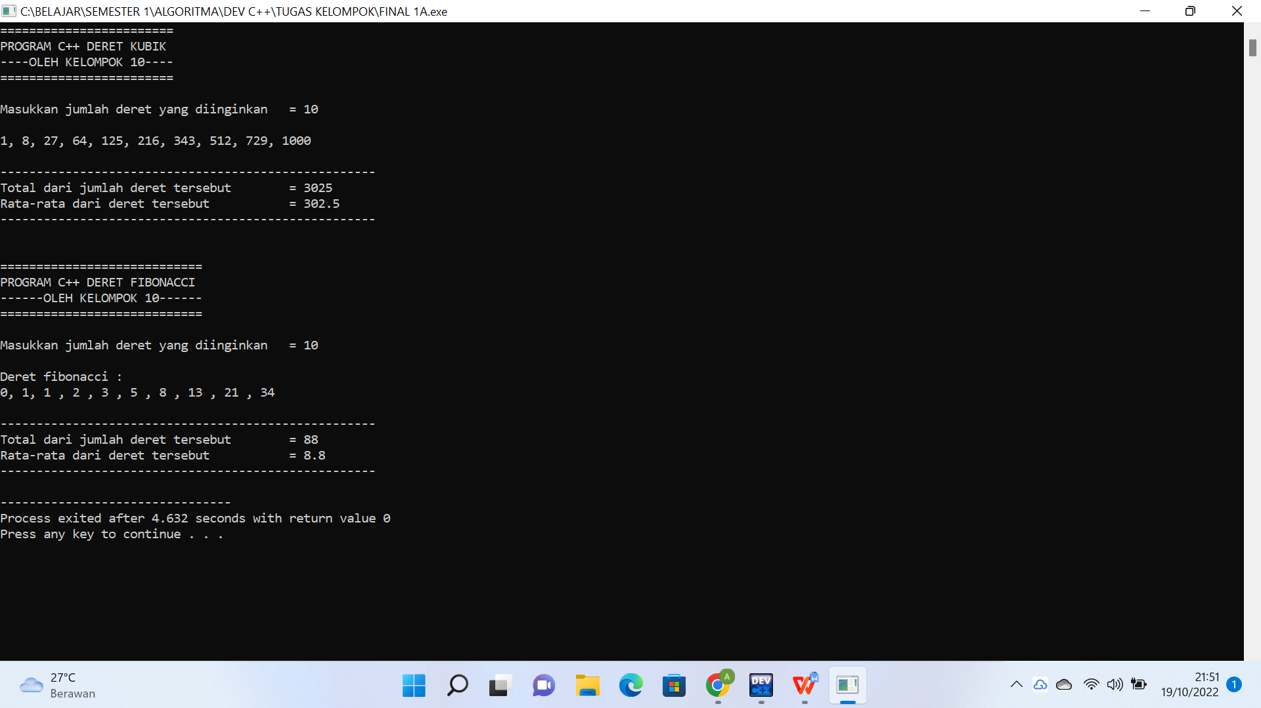

**1B. MEMBUAT PROGRAM DERET FAKTORIAL DAN DERET PRIMA**

#include<iostream>

using namespace std;

int main(){

//MEMBUAT PROGRAM DERET FAKTORIAL

cout<<"=========================================="<<endl;

cout<<"## Program C++ Deret Bilangan Faktorial ##"<<endl;

cout<<"-------------OLEH KELOMPOK 10-------------"<<endl;

cout<<"=========================================="<<endl;

cout<<endl;

int n, i;

long double hasil;

cout<<"Masukkan bilangan yang ingin difaktorialkan : ";

cin >>n;

cout<<endl;

cout<<n<<"! = ";

hasil = 1;

for ( i = n ; i >= 1; i--){

hasil = hasil*i;

//untuk menampilkan angka

cout<< i;

if(i != 1){

cout<<" * ";

}

}

cout<<" = "<<hasil<<endl;

cout<<"Hasil dari "<<n<<" faktorial adalah "<<hasil<<endl;

//PROGRAM DERET FAKTORIAL SELESAI

cout<<"\n\n======================================"<<endl;

cout<<"## Program C++ Deret Bilangan Prima ##"<<endl;

cout<<"-----------OLEH KELOMPOK 10-----------"<<endl;

cout<<"======================================"<<endl;

cout<<endl;

int batas, bil;

cout<<"Masukkan batas bilangan prima yang diinginkan : ";

cin>>batas;

cout<<endl;

cout<<"Deret bilangan prima : "<<endl;

for(int a = 1 ; a <= batas ; a++){

bil = 0;

for(int b = 1 ; b <= a; b++){

if(a % b == 0){

bil = bil + 1;

}

}

if(bil == 2){

cout<<a<<" ";

}

}

cout<<endl;

//PROGRAM DERET PRIMA SELESAI

return 0;

}

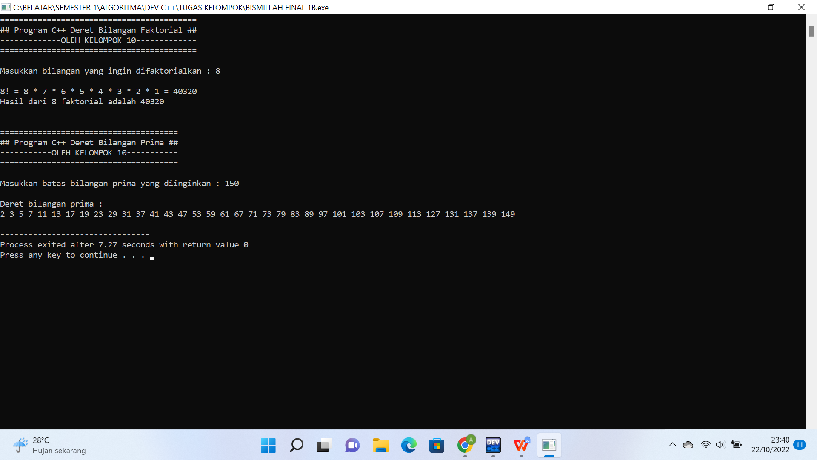

**2A. MEMBUAT PROGRAM PERHITUNGAN LUAS SEGITIGA DAN LUAS PERMUKAAN KUBUS**

#include <iostream>

using namespace std;

int main (){

//MEMBUAT PROGRAM MENGHITUNG LUAS SEGITIGA

cout<<"=========================================="<<endl;

cout<<"## Program C++ Menghitung Luas Segitiga ##"<<endl;

cout<<"-------------OLEH KELOMPOK 10-------------"<<endl;

cout<<"=========================================="<<endl;

cout<<endl;

int alas, tinggi, at;

float luas;

cout<< "Masukkan alas \t\t= ";

cin>>alas;

cout<<"Masukkan tinggi \t= ";

cin>>tinggi;

cout<<"--------------------------------"<<endl;

cout<<"\nAlas \t\t\t= "<<alas<<" cm "<<endl;

cout<<"Tinggi \t\t\t= "<<tinggi<<" cm "<<endl;

cout<<"--------------------------------"<<endl;

at = alas*tinggi;

luas = (alas*tinggi)/2;

cout<<"\nLuas segitiga = "<<endl;

cout<<"L = (alas x tinggi) : 2"<<endl;

cout<<"L = (a x t) : 2"<<endl;

cout<<"L = ("<<alas<<" x "<<tinggi<<") : 2 "<<endl;

cout<<"L = ("<<at<<") : 2"<<endl;

cout<<"L = "<<luas<<endl;

cout<<"\nLuas segitiga tersebut adalah "<<luas<<" cm2 "<<endl;

//PROGRAM MENGHITUNG LUAS SEGITIGA SELESAI

//MEMBUAT PROGRAM MENGHITUNG LUAS KUBUS

cout<<"\n\n========================================"<<endl;

cout<<"## Program C++ Menghitung Luas Kubus ##"<<endl;

cout<<"------------OLEH KELOMPOK 10------------"<<endl;

cout<<"========================================"<<endl;

cout<<endl;

int sisi, luas_kubus, ss; //ss = sisi x sisi

cout<<"Masukkan panjang sisi : ";

cin>>sisi;

cout<<"\nSisi (s) = "<< sisi <<" cm "<<endl;

ss = sisi*sisi;

luas_kubus = 6*(sisi*sisi);

cout<<"\nLuas Permukaan Kubus = "<<endl;

cout<<"L = 6 x (sisi x sisi)"<<endl;

cout<<"L = 6 x ("<<sisi<<" x "<<sisi<<")"<<endl;

cout<<"L = 6 x "<<ss<<endl;

cout<<"L = "<<luas_kubus<<endl;

cout<<"\nLuas permukaan kubus tersebut adalah "<<luas_kubus<<" cm2 "<<endl;

return 0;

}

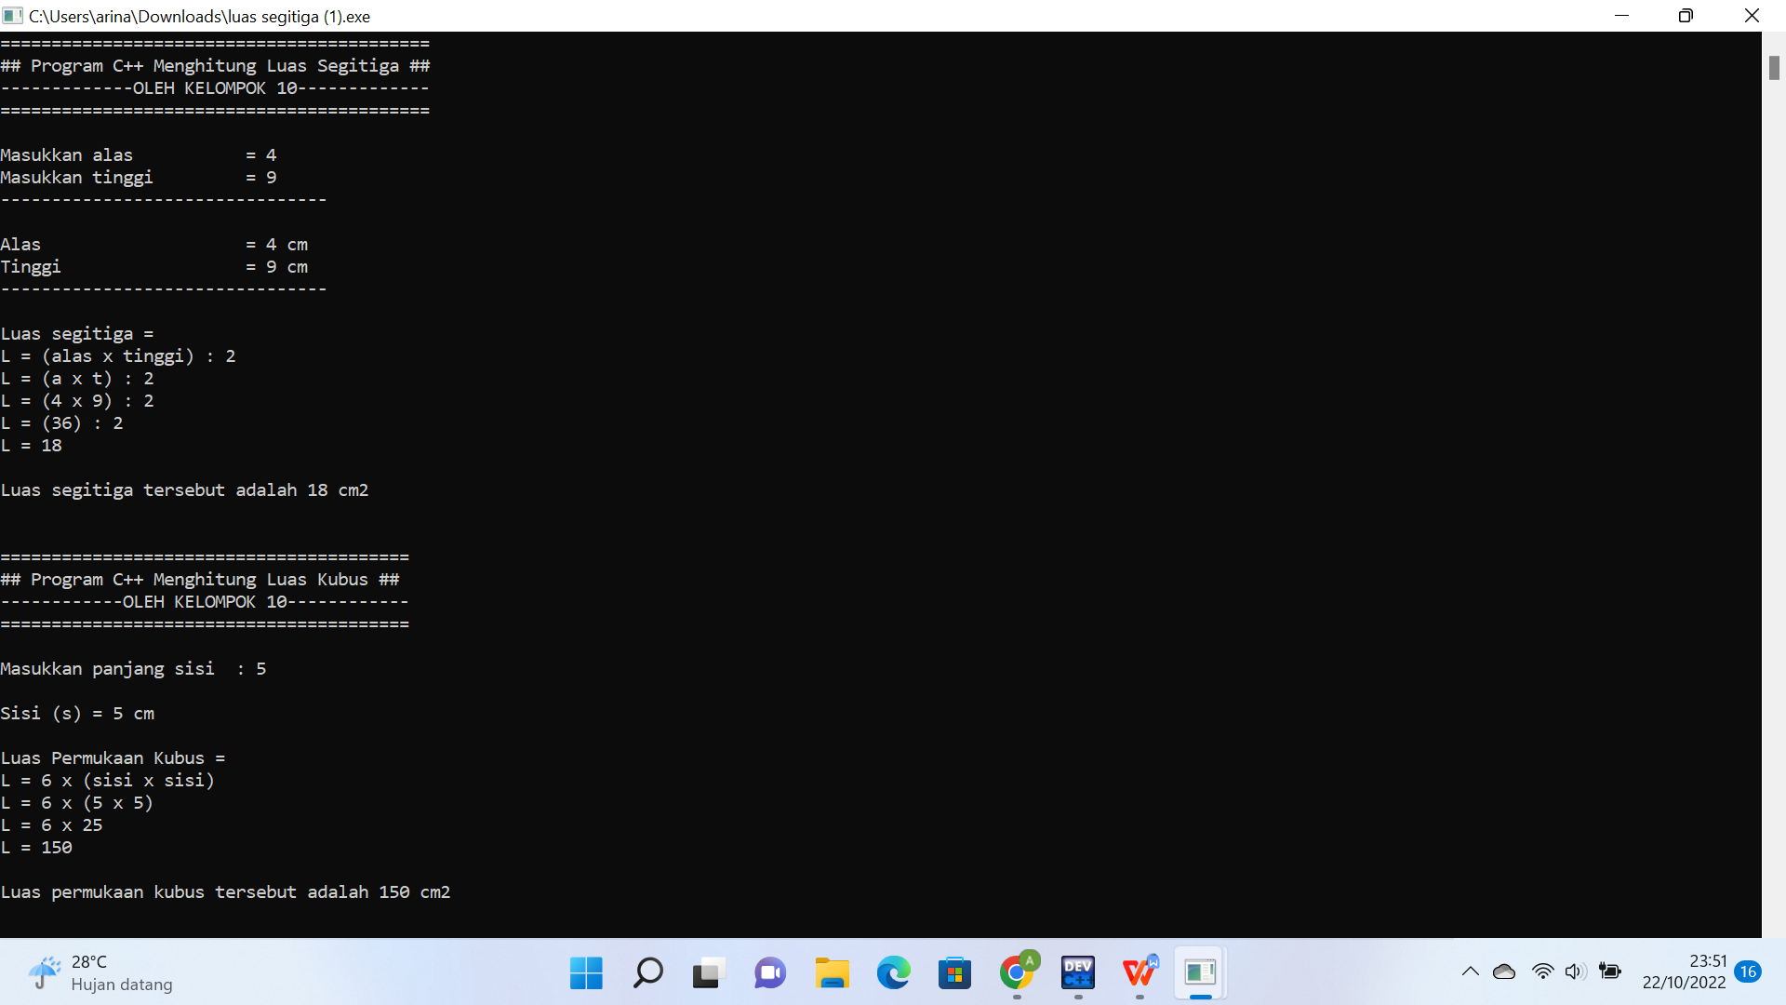

**2B. MEMBUAT PROGRAM PERHITUNGAN LUAS LINGKARAN DAN LUAS PERMUKAAN ISI BOLA**

#include <iostream>

using namespace std;

int main (){

//MEMBUAT PROGRAM MENGHITUNG LUAS LINGKARAN

cout<<"==========================================="<<endl;

cout<<"## Program C++ Menghitung Luas Lingkaran ##"<<endl;

cout<<"-------------OLEH KELOMPOK 10--------------"<<endl;

cout<<"==========================================="<<endl;

cout<<endl;

float phi, luas, jari_jari, r2, r3, luas1;

cout<< "Masukkan jari-jari lingkaran (r) = ";

cin>>jari_jari;

cout<<"-------------------------------------------"<<endl;

cout<<"\nJari-jari (r) \t\t\t = "<<jari_jari<<" cm "<<endl;

cout<<"-------------------------------------------"<<endl;

phi = 3.14;

r2 = jari_jari*jari_jari;

luas = phi * (jari_jari*jari_jari);

cout<<"\nLuas lingkaran = "<<endl;

cout<<"L = phi x (jari-jari x jari-jari)"<<endl;

cout<<"L = phi x (r x r)"<<endl;

cout<<"L = 3,14 x ("<<jari_jari<<" x "<<jari_jari<<")"<<endl;

cout<<"L = 3,14 x ("<<r2<<") "<<endl;

cout<<"L = "<<luas<<endl;

cout<<"\nLuas lingkaran tersebut adalah "<<luas<<" cm2 "<<endl;

//PROGRAM MENGHITUNG LUAS LINGKARAN SELESAI

//MEMBUAT PROGRAM MENGHITUNG VOLUME ISI BOLA

cout<<"\n============================================="<<endl;

cout<<"## Program C++ Menghitung Volume Isi bola ##"<<endl;

cout<<"---------------OLEH KELOMPOK 10--------------"<<endl;

cout<<"============================================="<<endl;

cout<<endl;

cout<< "Masukkan jari-jari bola (r) \t= ";

cin>>jari_jari;

cout<<"---------------------------------------------"<<endl;

cout<<"\nJari-jari (r) \t\t\t= "<<jari_jari<<" cm "<<endl;

cout<<"---------------------------------------------"<<endl;

phi = 3.14;

r3 = jari_jari*jari_jari*jari_jari;

luas1 = (4 * phi * (jari_jari*jari_jari*jari_jari));

luas = (4 * phi * (jari_jari*jari_jari*jari_jari))/3;

cout<<"\nVolume isi bola = "<<endl;

cout<<"L = 4/3 x phi x (jari-jari x jari-jari x jari-jari)"<<endl;

cout<<"L = 4/3 x phi x (r x r x r)"<<endl;

cout<<"L = 4/3 x 3,14 x ("<<jari_jari<<" x "<<jari_jari<<" x "<<jari_jari<<")"<<endl;

cout<<"L = 4/3 x 3,14 x ("<<r3<<") "<<endl;

cout<<"L = ("<<luas1<<")/3 "<<endl;

cout<<"L = "<<luas<<endl;

cout<<"\nVolume isi bola tersebut adalah "<<luas<<" cm3 "<<endl;

//PROGRAM MENGHITUNG VOLUME ISI BOLA SELESAI

return 0;

}

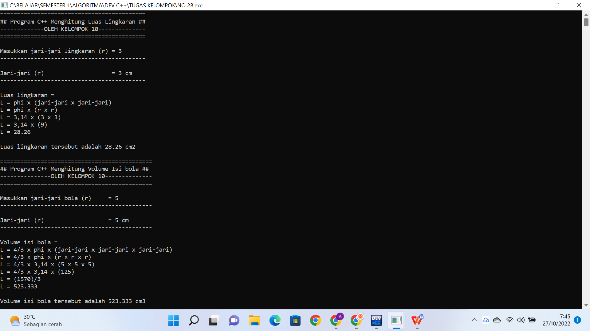

**3A. MEMBUAT PROGRAM DERET BILANGAN GENAP DAN DERET BILANGAN GANJIL**

#include <iostream>

using namespace std;

int main (){

//MEMBUAT PROGRAM DERET BILANGAN GENAP

cout<<"=================================================="<<endl;

cout<<" ## Program C++ DERET BILANGAN GENAP & GANJIL ## "<<endl;

cout<<"-----------------OLEH KELOMPOK 10-----------------"<<endl;

cout<<"=================================================="<<endl;

cout<<endl;

int batas_genap, batas_ganjil;

cout<<"--------------------------------------------------"<<endl;

cout<<"Masukkan batas deret genap yang diinginkan = ";

cin>>batas_genap;

cout<<"--------------------------------------------------"<<endl;

cout<<endl;

cout<<"Deret bilangan genap : "<<endl;

for(int a = 1 ; a <= batas_genap ; a++){

if (a % 2 == 0){

cout<<a;

if (a != batas_genap && a != (batas_genap - 1)){

cout<<", ";

}

}

}

cout<<endl;

//PROGRAM DERET BILANGAN GENAP SELESAI

//MEMBUAT PROGRAM DERET BILANGAN GANJIL

cout<<"\n\n-------------------------------------------------- "<<endl;

cout<<"Masukkan batas deret ganjil yang diinginkan = ";

cin>>batas_ganjil;

cout<<"--------------------------------------------------"<<endl;

cout<<endl;

cout<<"Deret bilangan ganjil : "<<endl;

for(int b = 1 ; b <= batas_ganjil ; b++){

if (b % 2 == 1){

cout<<b;

if (b != batas_ganjil && b != (batas_ganjil - 1)){

cout<<", ";

}

}

}

cout<<"\n\n"<<endl;

//PROGRAM DERET BILANGAN GENAP SELESAI

return 0;

}

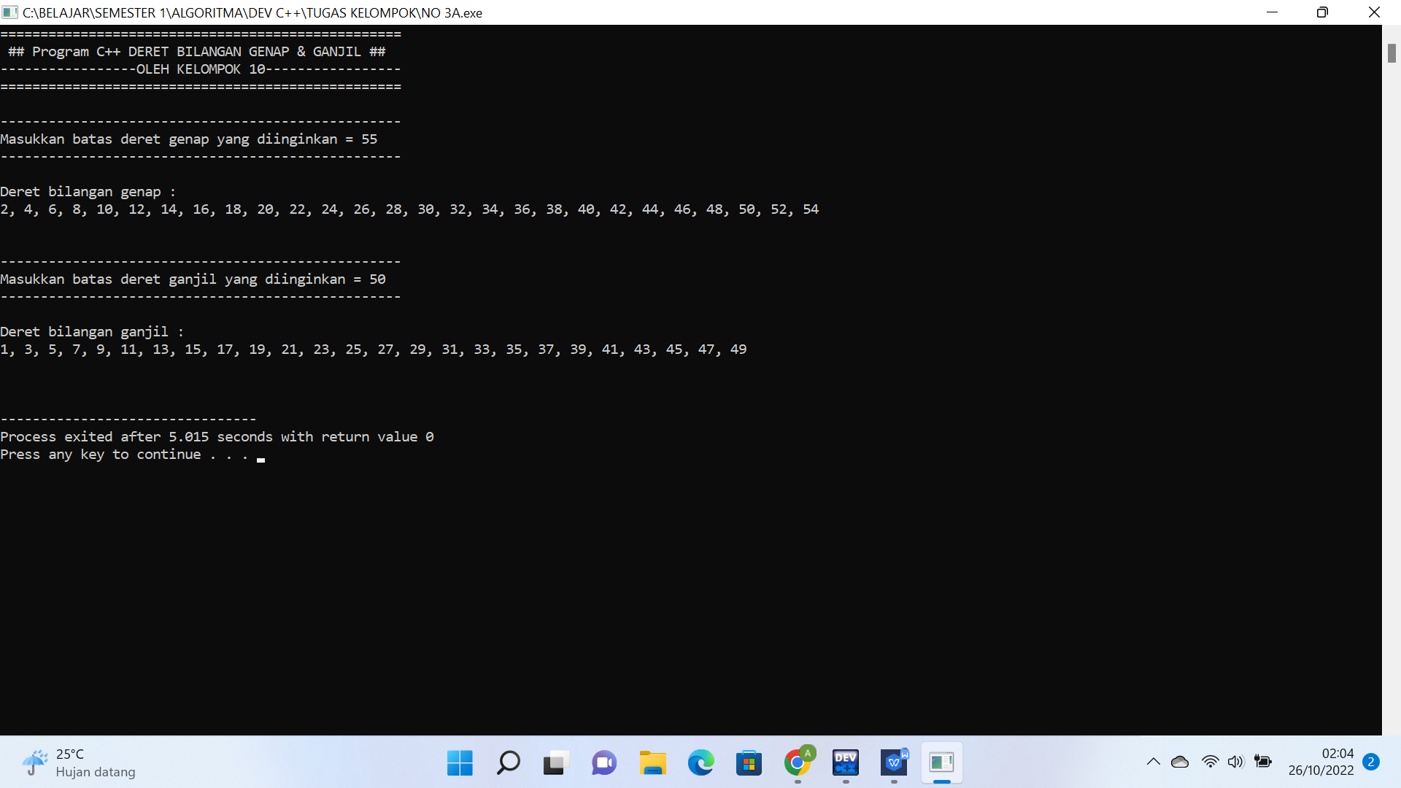

**3B. MEMBUAT PROGRAM DERET BILANGAN INCREMENT DAN DECREMENT**

#include <iostream>

using namespace std;

int main (){

//MEMBUAT PROGRAM DERET BILANGAN INCREMENT (MENAIK)

cout<<"======================================================="<< endl;

cout<<" ## Program C++ DERET BILANGAN INCREMENT & DECREMENT ## "<<endl;

cout<<"-------------------OLEH KELOMPOK 10-------------------- "<<endl;

cout<<"======================================================="<< endl;

cout<<endl;

int batas_increment, batas_decrement;

cout<<"------------------------------------------------------- "<<endl;

cout<<"Masukkan batas deret increment diinginkan = ";

cin>>batas_increment;

cout<<"------------------------------------------------------- "<<endl;

cout<<endl;

cout<<"Deret bilangan increment (menaik) : "<<endl;

for(int a = 1 ; a <= batas_increment ; a++){

cout<<a;

if (a != batas_increment){

cout<<", ";

}

}

cout<<endl;

//PROGRAM DERET BILANGAN INCREMENT (MENAIK) SELESAI

//MEMBUAT PROGRAM DERET BILANGAN DECREMENT (MENURUN)

cout<<"\n\n------------------------------------------------------ -------------------"<<endl;

cout<<"Masukkan bilangan yang diinginkan untuk memulai deret decrement = ";

cin>>batas_decrement;

cout<<"---------------------------------------------------------- ---------------"<<endl;

cout<<endl;

cout<<"Deret bilangan decrement (menurun) : "<<endl;

for(int b = batas_decrement ; b >= 1 ; b--){

cout<<b;

if (b != 1){

cout<<", ";

}

}

cout<<"\n\n"<<endl;

//PROGRAM DERET BILANGAN DECREMENT (MENURUN) SELESAI

return 0;

}

